**Ubuntu Installation (Windows version)**

1. You must have windows 10 and updated.
2. Open Microsoft Store from the start.

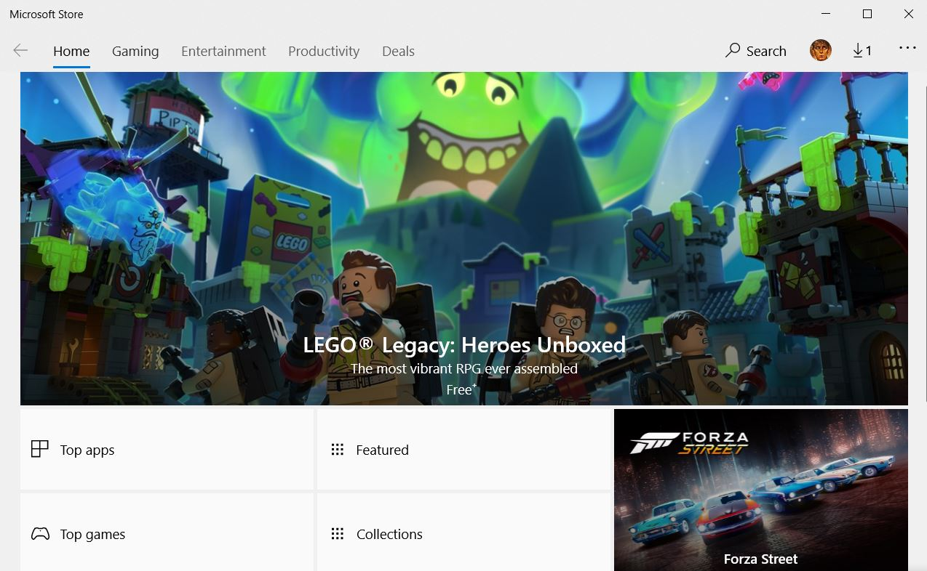

1. In the search field, type “ubuntu” and select ubuntu 18.04 Lite. After installing it proceed to step 4.

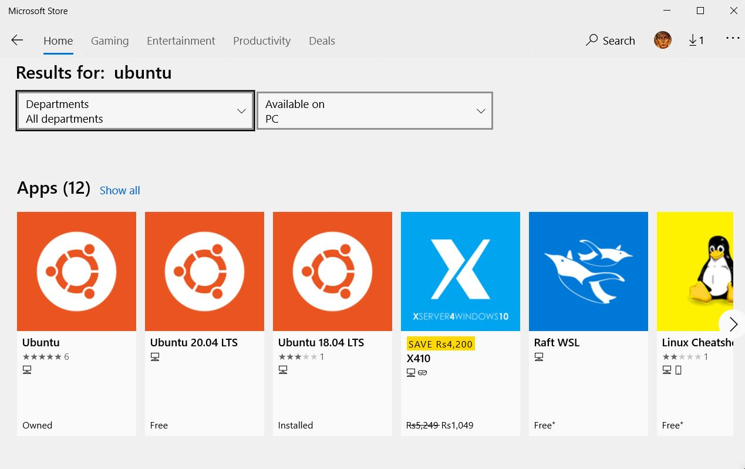

1. Now go back to start and choose “settings”.
2. 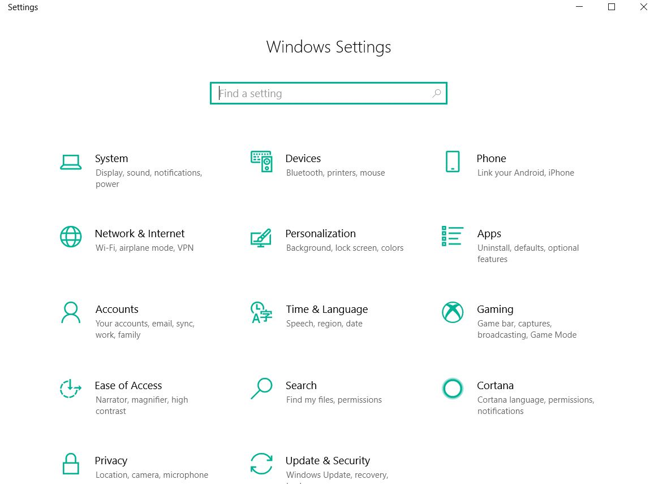In the settings click on “Update & Security”.
3. From the left pane select “For Developers”. In this check the “Developer Mode” circle.
4. Wait for a bit, while all the necessary packages are downloaded.
5. After all the packages are downloaded click on the start again and type “Turn Windows Features On & Off”.
6. In this new window, scroll down to check the box “Windows Subsystem for Linux”.

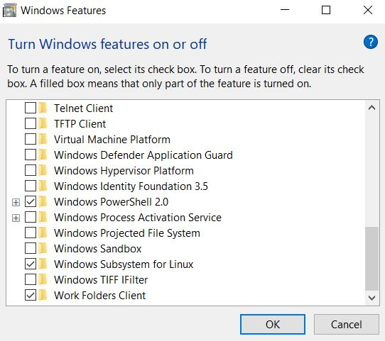

1. Wait for a bit here too, while all the necessary files are downloaded.
2. After this you will be prompt to restart your PC. Restart!
3. After you have successfully rebooted your PC, turn on Ubuntu 18.04 Lite from the Microsoft Store by pressing the launch icon.
4. Here you will be asked for username and password.
5. Choose username and password such that all letters must be small, short and without spaces.
6. After you have successfully set the username and password, type in following command: **sudo** **apt-get install build-essential**
7. Remember to press “**TAB**” after this command and then press enter.
8. Resolve errors if any and run the same command in step 15 &16 again.
9. Wait a bit here too, while all the packages are installed properly.
10. Your Ubuntu is ready to work. You might want to navigate to your drives e.g. c, d, e etc. To do so experiment with “**cd ..**” and “**ls**” commands and find a file called “**mnt**”. Inside it you will find all your drives.
11. Enjoy.